**MINISTRY OF EDUCATION AND TRAINING**

**UNIVERSITY OF DANANG**

Logo-UD

### PROJECT PLAN

**[DANANG BUS ROUTES FINDER “DANABUS"]**

VERSION: [1.02] REVISION DATE: [2019 April 2nd]

***Danang, 2019***

Approval of the Project Plan indicates an understanding of the purpose and content described in this document and the related, attached plans for communication, configuration, performance, and risk management. Approval of the Project Plan constitutes approval of the Project Plan and the related plans. By signing this document, each individual agrees the project has been planned effectively as described herein.

|  |  |  |
| --- | --- | --- |
| **Agency Head** | | |
| [Ngoc Trong Be] | [ntbess@iic.com] | [0123568462] |
| Signature | | Date |

|  |  |  |
| --- | --- | --- |
| **Executive Sponsor** | | |
| [An An Nguyen] | [an@ahqua.com] | [09684321567] |
| Signature | | Date |

|  |  |  |
| --- | --- | --- |
| **Project Manager** | | |
| [Quoc Tran Anh Viet] | [quoc@ahaq.com] | [0235461357] |
| Signature | | Date |

|  |  |  |
| --- | --- | --- |
| **IT Director** | | |
| [Hieu Le Trong] | [hieu@ahaq.com] | [093546846] |
| Signature | | Date |

|  |  |  |
| --- | --- | --- |
| **Scrum Master** | | |
| [Van Anh Truong] | [vanh@ahaq.com] | [0120123124] |
| Signature | | Date |

**Contents**

Section 1. Project Overview 1

Section 2. Project Organization 4

Section 3. Project Start-Up 9

Section 4. Monitoring and Control 19

Section 5. Quality Management 23

Section 6. Project Transition 26

Section 7. References 27

Section 8. Glossary 28

Section 9. Revision History 30

Section 10. Appendices 31

# Section 1. Project Overview

* 1. **Project Description**

Public buses have long been recognized as a solution for urban problems and difficult transportation problems such as environmental pollution, noise pollution, traffic jams, traffic accidents, etc… In Da Nang city, TMF modern bus system has been put into operation, however, people are still not really impressed by public transport systems.

One of the key challenges faced nowadays by public transportation authorities is to offer personalized services to citizens. This requires the new Information and Communication Technologies (ICT) to be massively exploited. Aim to attract the community to use the bus with the best experience, the goal of this project “Danabus” not only to develop some of the core features of a system that can help a Da nang Metropolitan Transportation system improve the offered services to citizens but also help improve the city transport system, reduce emissions to protect the environment.

Danabus App is used for look up bus routes in Da Nang city. In particular:

* Look up bus routes and track bus locations in real time to help users know detailed information about bus routes, exactly when cars arrive at the station, take the initiative in arranging time and pick up cars bus, reduce waiting time.
* Find the optimal route from starting point and end point. In case of having to use multiple trips to reach the end point, the application helps to indicate the point of departure and exchange.
  1. **Project Sc****ope**

|  |
| --- |
| **Project Includes** |
| * Application run on mobile devices only:   + Apple iPhone devices: iOS 9.0 or above, includes (iPhone 4s, iPhone 5, iPhone 5c, iPhone 5s, iPhone 6, iPhone 6 Plus, iPhone 7, iPhone 7 Plus, iPhone 8, iPhone 8 Plus, iPhone X, iPhone XS/XS Max, iPhone XR).   + Android devices: Android 5.0 or above (updated OS version after 2014, Oct 15th). * Application will be available on App Store (for iPhone devices) and Google Play Store (for Android devices). |
| * Language: Vietnamese & English |
| * Connection:   + GPS, for discovering user location. If GPS is not available, application will run only on some limited functions.   + Internet access. If internet access is not available, application will run only on some limited functions. |
| * Find routes:   + Show users the best ways to travel between 2 locations. |
| * Estimate waiting time:   + Estimate the time the bus will arrive at any station, based on real-time data from the bus GPS device. |
| * Look up information:   + Look up detailed information of each bus route: departure time, passing stations |
| * Find bus stop:   + Search for the bus stop location near the current user location, visually display on the map. |
| * Update data:   + The application can update real time data from the centralized  server system of Danang ICT Infrastructure Development Center. |
| * Feedback:   + User can give feedback about bus quality to the Operations Center. |

|  |
| --- |
| **Project Excludes** |
| * The only delivered products and services are the mobile applications on Android and iOS system. There is no Webpage, Windows Application or MacOS application for this. Any other Marketing, Advertisement or businesses is not included in this project. |
| * This project used Google Maps data, some features such as find optimal routes will not work outside Da Nang city and some Quang Nam province area (i.e areas that contain bus routes under Datramac’s control). |
| * There is no User Login or Register function in this Application. |

* 1. **Assumptions**

|  |
| --- |
| **Assumptions** |
| * Resource assumptions:   + Project leader and members will not leave (Man power will stay the same).   + No unexpected natural & artificial incidents occur during the project (ex: incoming storms, human diseases, unexpected electricity shutdown cause data lost, ...).   + Data about routes or buses will be provided by Danang ICT Infrastructure Development Center ontime.   + All the open source data provider (ex: Google Maps,... ) will not change their policy in at least 2 years. |
| * Technology assumptions:   + Every bus will be equipped with a GPS device.   + City’s wireless infrastructure will meet the project requirement.   + No big change in software industry technology (ex: iOS, Android, programming languages like Swift, Java, ... will not likely change to a new un-backward-compatible version). |
| * Business assumptions:   + All the process that delivery the application to the user like marketing or advertisement will be done well by the city’s media (ex: every bus stop will have ads about the application, …).   + City government will continue supporting on making the people change their habit from using personal motorbike to public transport like bus.   + People will have a habit of using the bus more. The number of buses on the road in Da Nang city is also expected to increase rapidly after the application is released.   + The city’s government has carefully specify all needed requirement, no new requirement arise. |
| * Financial assumptions:   + City’s overall economical conditions will stay the same. (i.e. personnel cost, day-to-day activity cost will not change, ...).   + Pre-calculated cost error of the project is under 5%.   + The city’s government will pay for all the project’s cost, including the maintenance and development cost of the application after it has been released. |

* 1. **Constraints**

|  |
| --- |
| **Constraints** |
| * Schedule constraints   + Project will start at 2019, March 9th. and final product must be delivered before 2020, June 1st to meet the city’s Department of Transport’s requirement.   + Project prototype and project progress must be reported with all stakeholder once a month.   + Application beta version must be released before 2019, November 30th in order to collect user feedback . |
| * Scope constraints   + All of main features: find optimal bus route, find bus stop, bus schedule details, estimate waiting time and feedback must be available at beta version.   + The application must meet the target of 3.5/5 stars or receive over 100 feedback from users on the App Store and Google Play Store since the release of the beta version until 2020, June 1st |
| * Cost constraints   + Project budget: 30000$.   + 3 back-end developers, 3 front-end developers and 2 testers are required.   + Application server can handle 10000 user access at one time. |

# Section 2. Project Organization

* 1. **Internal Structure**

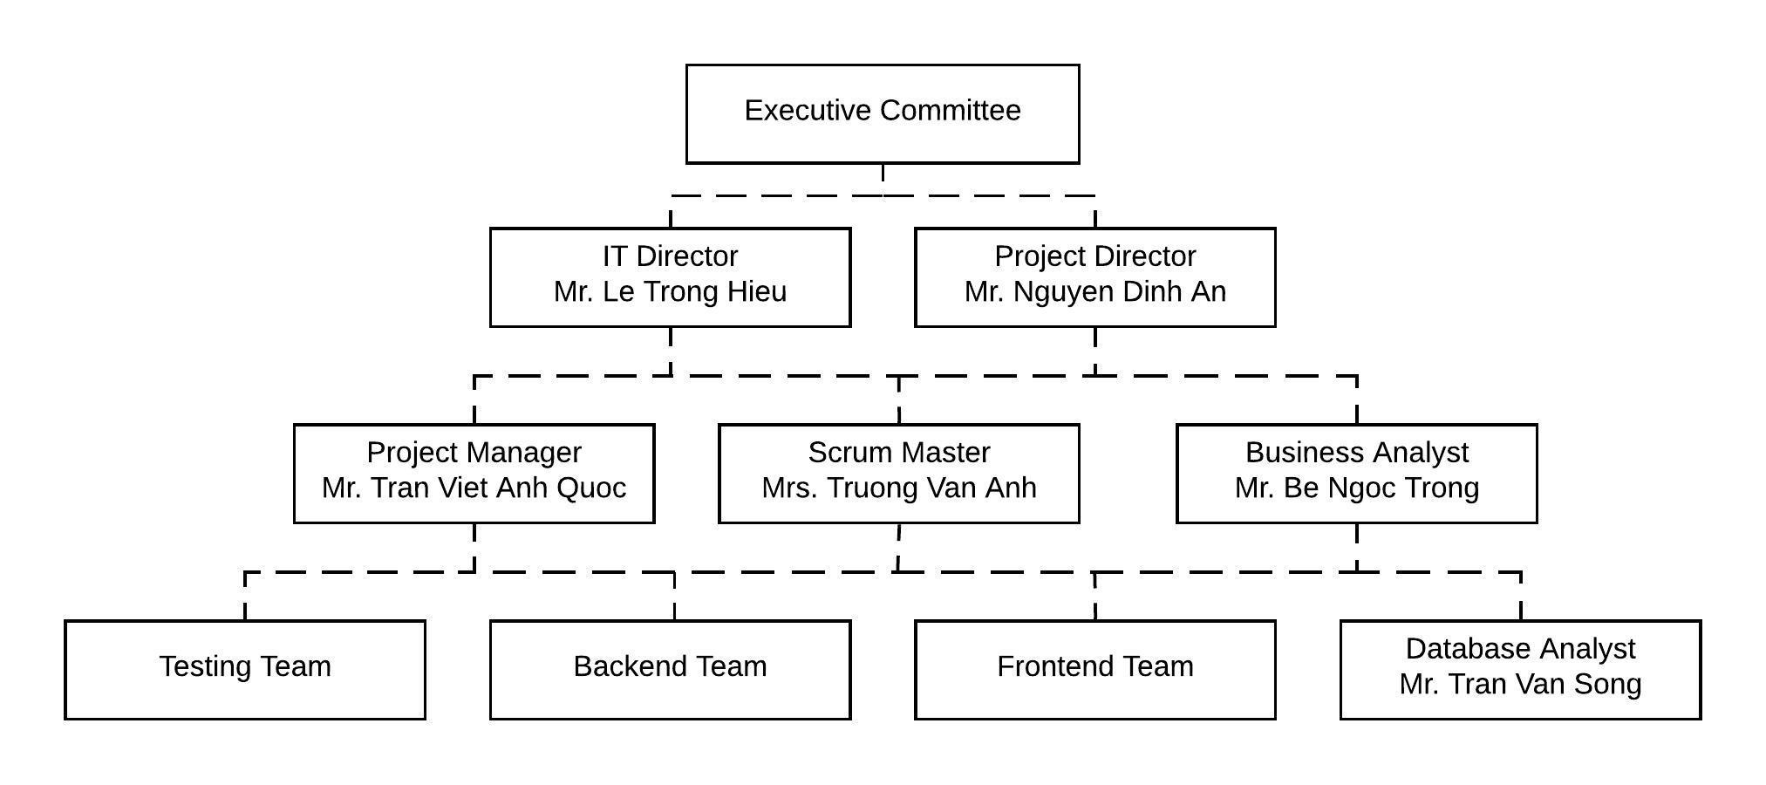

* 1. **External S****takeholders**

|  |  |  |
| --- | --- | --- |
| **Stakeholder Organization** | **Organization Description/Nature of Relationship** | **Stakeholder Name** |
| Danang Government | Agency for licensing and authorizing projects | Government |
| Danang DoT | Direct customer of the company | Customer |
| Danang IIDC | The agency provides hardware and assists the company in product deployment | Supplier |

* 1. **Roles and Responsibilities**

|  |  |
| --- | --- |
| **Role** | **Responsibility** |
| Executive Committee | Responsible for ensuring and supervising projects implemented and completed.  Responsible for communication between stakeholders & project team. |
| IT Director | Responsible for technical, security and application deployment. |
| Project Director | Responsible for allocating personnel to the project.  Develops a timeline for the completion of certain milestones for a given project . Creates a budget for the completion of a particular job, and monitors the amount of money spent in order to ensure the project does not exceed this amount. Recommends changes to a project that is ongoing if it appears it is not proceeding on schedule or is producing unsatisfactory results.  Reviews proposals and approves or denies them. |
| Project Manager | Designing and applying appropriate project management standards.  Managing the production of the required deliverables.  [Planning](https://www.finance-ni.gov.uk/articles/programme-and-project-planning) and monitoring the project.  Adopting any delegation and use of project assurance roles within agreed reporting structures.  Preparing and maintaining [project, stage and exception plans](https://www.finance-ni.gov.uk/publications/templates-programmes-or-projects) as required.  Managing project [risks](https://www.finance-ni.gov.uk/articles/programme-and-project-risk-management), including the development of contingency plans.  Liaison with project director & stakeholder who related projects to ensure that work is neither overlooked nor duplicated.  Monitoring overall progress and use of resources, initiating corrective action where necessary. |
| Scrum Master | Clearing obstacles.  Establishing an environment where the team can be effective.  Addressing team dynamics.  Ensuring a good relationship between the team and [product owner](https://www.agilealliance.org/glossary/product-owner/) as well as others outside the team.  Protecting the team from outside interruptions and distractions. |
| Database Analyst | Administer all database projects and ensure compliance to deadlines.  Analyze all databases and monitor it for all design specifications and prepare associate test strategies.  Design and perform various tests on all systems.  Develop and perform tests all relational database systems sourced from vendors or internal.  Monitor efficient quality of data for enterprise.  Analyze systems and prepare reports for status of projects and submit it to user management.  Perform regular analysis on all application software for organization.  Monitor all queries from clients and managers and assist in effective resolution.  Manage and resolve all customer queries and provide all data extraction techniques for various businesses.  Design and maintain various database environments on SQL server.  Design and evaluate an efficient backup recovery process for various databases.  Prepare reports for various databases.  Identify and resolve all problems and ensure appropriate tracking of issues on same.  Analyze all database statistics and recommend changes if required.  Monitor all internal and external data feeds for systems. |
| Business Analyst | Evaluating business processes, anticipating requirements, uncovering areas for improvement, and developing and implementing solutions.  Leading ongoing reviews of business processes and developing optimization strategies.  Staying up-to-date on the latest process and IT advancements to automate and modernize systems.  Conducting meetings and presentations to share ideas and findings.  Performing requirements analysis.  Documenting and communicating the results of your efforts.  Effectively communicating your insights and plans to cross-functional team members and management.  Gathering critical information from meetings with various stakeholders and producing useful reports.  Allocating resources and maintaining cost efficiency.  Ensuring solutions meet business needs and requirements.  Managing projects, developing project plans, and monitoring performance. |
| Testing Team | Read all the documents and understand what needs to be tested.  Based on the information procured in the above step decide how it is to be tested.  Develop test cases and prioritize testing activities.  Execute all the test case and report defects, define severity and priority for each defect. |
| Backend Team | Compile and analyze data, processes, and codes to troubleshoot problems and identify areas for improvement.  Collaborate with the front-end developers and other team members to establish objectives and design more functional, cohesive codes to enhance the user experience.  Recording data and reporting. |
| Frontend Team | Develop new user-facing features.  Build reusable code and libraries for future use.  Ensure the technical feasibility of UI/UX designs.  Optimize application for maximum speed and scalability.  Assure that all user input is validated before submitting to back-end.  Collaborate with other team members and stakeholders. |
| Danang Government | Responsible for licensing if necessary. Responsible for supervising projects that have been completed as required.  Responsible for disbursement follow by each stage. |
| Danang DoT | Providing the information to the project team about their demands and requests.  Consideration and confirmation of the statute.  Taking part on the team of the project when required.  Providing the intelligence about any modifications in the close quarters situation which are able to influence the ultimate deliverables of the project;  Confirmation of the modifications within the software project when necessary in order to provide a successful execution of the project.  Consideration of the status project records.  Estimation of the ultimate deliverables and the whole process of the project.  The customers inside the company can likewise play several supplementary roles.  Consideration and confirmation of the whole plan of the project. |
| Danang IIDC | Responsible for providing resources if needed.  Collaborate with Database Analyst to discussing options for hardware deployment, information systems. Responsible for user security systems, ensuring resources are always active. |

# Section 3. Project Start-Up

* 1. **Project Life Cycle**

This is a Software Developemnt project, so we will call our project life cycle is Software Development Life Cycle (SDLC). With this project, we don’t have pressure of time, but we must make our product stable as much as possible, because we don’t want the city’s bus system crash. So the SDLC model we will apply in this product is V-Model – to emphasize the testing process.

Project’s product and services delivery life cycle will consist of 6 phases: requirement analysis, feasibility study, design, coding, testing, deploying and maintenance.

Phase 1: The requirement is conducted by the senior team members with inputs from all the stakeholders, including Danang’s Department of transportation representative, Danang ICT Infrastructure Development Center and project manager, Mr Quoc

Phase 2: Once the requirement analysis phase is completed the next step is to define software needs:

* Economic: The city’s government has commited to provide all related costs.
* Legal: sure it’s legal. Currently there are no others bus routing system in Da Nang.
* Technical: We have design a similar system for another city, and all the bus data is provided by Da Nang ICT Infrastructure Development Center, so the technical is not a big problem.
* Schedule: As said above, we have design a similar system for another city, thus we know exactly the time we need.

Phase 3: Design:

* High-Level Design (HLD):
  + Brief description and name of each module
  + An outline about the functionality of every module
  + Interface relationship and dependencies between modules
  + Database tables identified along with their key elements
  + Complete architecture diagrams along with technology details
  + Low-Level Design(LLD)
* Functional logic of the modules:
  + Database tables, which include type and size
  + Complete detail of the interface
  + Addresses all types of dependency issues
  + Listing of error messages
  + Complete input and outputs for every module

Phase 4: Coding.

Phase 5: Installing/Deployment.

Phase 6: Maintenance.

The testing process will be executed parallel with all phases.

More over, we will apply “IEEE 12207-2017 - ISO/IEC/IEEE International Standard - Systems and software engineering -- Software life cycle processes” standard to this project.[1]

* 1. **Methods, T****ools, and Techniques**

As stated above, this project will be applied with V-Model method – an extension of the waterfall model.

The project’s product will be written in Java – for Android platform, and Swift – for iOS platform. We will use company’s Github code repository to manage codes.

The standards detailed standard for this project will be specified in a different document. Here are outline of the things that must be standardized in this project.

**3.2.1 System Development Standards**

- Naming conventions for files (permanent and temporary), procedures, variables, test files.

- Buffering and blocking requirements for files.

- Directory structures (i.e., where components such as source code, object files, test files, control procedures, and screens are located).

- Annotation standards (e.g., comments required at the beginning of each program include revision history, procedure, and logic comments).

**3.2.2 Documentation Standards**

- Update of Project Encyclopedia documentation to include additional documentation.

- Format of documentation required (e.g., detailed Pseudocode, program schematics, updated edit rules).

- Level of detail required for program documentation (e.g., high-level Pseudocode versus Pseudocode that matches the procedure line-by-line).

- Deliverable package required (e.g., written documentation, program listing, screen listing, test cases, expected and actual results, command files used by the procedure).

**3.2.3 Program Standards**

- Logical flow of procedures within a program (e.g., require top-down flow of procedures).

- Maximum size and complexity of procedures.

- Separating input/output functions from computational functions.

- Error handling procedures.

- Sort/merge techniques (i.e., only allow use of system level sort/merge or allow sort/merges to be done within programs).

- Use of global versus local variables.

- Prohibiting the sharing of temporary intermediate storage between procedures.

- Use of copy members (e.g., use of routines/file definitions from the Project Encyclopedia).

- Use of general purpose routines from the Project Encyclopedia for I/O and re-use components (e.g., date checking routines, table checks).

- Use of centralized parameter assignments.

- Conventions for initializing I/O.

- Structures that are to be used in programs, e.g., whether GOTO statements will be allowed and how IF-THEN-ELSE and WHILE statements will be structured.

- Placement of non-executable statements.

- Indentation conventions.

- Maximum nesting levels of loops and branches.

- Prohibited use of constants as procedure call statements.

- Any standards peculiar to the semantic or syntactical forms of the programming language.

**3.2.4 Command File Standards**

- Annotation standards (e.g., comments required at the beginning of the file).

- Restrictions on length and complexity of command files.

- Error handling.

- Sort/merge conventions (e.g., requiring the output file to be different from the input file, blocking conventions).

- Modular command files.

**3.2.5 Test Case Standards**

- Minimum testing and test case documentation required.

- Documenting of test cases, expected results, and test data.

- Methods for running tests.

- Methods for documenting actual results.

- Methods for correcting errors and re-running test cases.

* 1. **Estimation Methods**

|  |  |
| --- | --- |
| Estimation Methods/Tools/Techniques | PERT – Project Evaluation and Review Technique |
| Description | PERT is based on three values − most optimistic estimate (O), a most likely estimate (M), and a pessimistic estimate (least likely estimate (L)). The most-likely estimate is weighted 4 times more than the other two estimates (optimistic and pessimistic). |
| Effort in person-months or person-hours | Assume that each people work 8h/day, 5days/week, 4 weeks/month. We have 17 months schedule.  => Persons-months value = 17*8*4*5/160 = 17 |
| Schedule in calendar months | 17 months |
| Budget in dollars | 250.000$ |
| Source/Basis of Estimate | - Arrive at the WBS.  - For each task, find three values most optimistic estimate (O), a most likely estimate (M), and a pessimistic estimate (L).  - Calculate the PERT Mean of the three values.  PERT Mean = (O + 4 × M + L)/3  - Calculate the Standard Deviation of the task.  Standard Deviation (SD) = (L − O)/6  - Repeat steps 2, 3, 4 for all the tasks in the WBS.  - Calculate the PERT estimate of the project.  E (Project) = ∑ E (Task)  - Calculate the Standard Deviation of the project.  SD (Project) = √ (ΣSD (Task)2) |
| Level of Uncertainty | The conversion is based such that  - Confidence level in E +/– SD is - approximately 68%.  - Confidence level in E value +/– 1.645 × SD is approximately 90%.  - Confidence level in E value +/– 2 × SD is approximately 95%.  - Confidence level in E value +/– 3 × SD is approximately 99.7%.  - The 95% confidence level, i.e., E Value + 2 × SD, is used for all project and task estimates. |

* 1. **Work Activities**
* **Product** Work Breakdown Structure:
* **Process** Work Breakdown Structure:
  1. **Schedule & Budget Allocation**

|  |  |  |  |  |  |
| --- | --- | --- | --- | --- | --- |
| Start date | End date | Activity | Duration(days) | Duration(month) | Cost,$ |
| 1/1/2018 | 11/20/2018 | Planning | 323 | 10.77 | 67,700.000 |
| 1/1/2018 | 12/19/2018 | Management | 352 | 11.73 | 97,250.000 |
| 2/9/2018 | 3/10/2018 | Requirements | 29 | 0.97 | 34,300.000 |
| 2/22/2018 | 3/13/2018 | Prototyping | 19 | 0.63 | 11,950.000 |
| 3/10/2018 | 12/30/2018 | Configuration management | 295 | 9.83 | 42,500.000 |
| 3/1/2018 | 4/10/2018 | Functional design | 40 | 1.33 | 78,600.000 |
| 3/19/2018 | 4/17/2018 | Design review 1 | 29 | 0.97 | 19,600.000 |
| 4/24/2018 | 6/23/2018 | Detail design | 60 | 2.00 | 80,350.000 |
| 6/4/2018 | 6/21/2018 | Design review 2 | 17 | 0.57 | 21,000.000 |
| 3/29/2018 | 1/12/2019 | Quality assurance | 289 | 9.63 | 27,500.000 |
| 5/10/2018 | 11/27/2018 | Coding | 201 | 6.70 | 322,200.000 |
| 6/26/2018 | 7/3/2018 | Reuse acquisition | 7 | 0.23 | 1,450.000 |
| 10/27/2018 | 1/21/2019 | Code inspections | 86 | 2.87 | 58,000.000 |
| 11/8/2018 | 2/4/2019 | Unit test | 88 | 2.93 | 25,950.000 |
| 1/25/2019 | 3/23/2019 | Function test | 57 | 1.90 | 80,400.000 |
| 2/8/2019 | 3/23/2019 | System test | 43 | 1.43 | 102,850.000 |
| 4/15/2019 | 5/10/2019 | Field test | 25 | 0.83 | 21,400.000 |
| 11/10/2018 | 3/5/2019 | User documents | 115 | 3.83 | 133,500.000 |
| 1/27/2019 | 3/24/2019 | Document reviews | 56 | 1.87 | 26,350.000 |
| 4/10/2019 | 6/7/2019 | Installation/Deployment | 58 | 1.93 | 67,150.000 |

* 1. **Resource Plan**
     1. **Resource Profiles**

Generally describe primary resources that will be needed for the project including personnel (FTE and contract), equipment, facilities, hardware, software, materials, supplies, and training.

* + 1. **Resource Detail**

For each of the resources described under Resource Profiles, provide information on the cost estimate, number of hours required, availability of each resource and skill set requirements. For non-personnel resources, such as facilities or hardware, indicate “not applicable” under skill set.

|  |  |  |  |  |  |
| --- | --- | --- | --- | --- | --- |
| **Resource** | **Cost Estimate** | **Estimated Hours** | **Availability** | **Skill Set** | **Work Product/Deliverable** |
| Project Manager | 17000 | Whole project | Whole project | Expert | Manage all project situation. |
| Developer | 59500 | Whole project | Whole project | Intermediate | Build 2 completely mobile app & able to maintain it after deployment |
| FTE Designer | 17000 | 19 days(prototyping stage) | Whole project | Intermediate | Design prototype UX-UI for 2 mobile application |
| Contract Designer | 10000 | 100 hours | When there are new incoming request about UI | Intermediate | Re-design from available designation |
| HR | 10000 | Whole project | Whole project | Intermediate | Able to manage team’s human resources situation |
| Consultant | 10000 | 100 hours | When project meets some hard requirement | Expert | Able to give advice for software architecture-level. |
| Licensed testing tool | 1000 | Whole project | Whole project | Not applicable | Execute test for whole project |
| Licensed IDE | 5000 | Whole project | Whole project | Not applicable | Support developer |
| Google Firebase account | 5000 | Whole project | Whole project | Not applicable | Support fast deployment, easier for testing |
| Android phones | 2000 | Whole project | Whole project | Not applicable | Support testing on real device |
| iPhones | 4000 | Whole project | Whole project | Not applicable | Support testing on real device |
| PCs | 10000 | Whole project | Whole project | Not applicable | Using on whole project |
| Working room | 0 | Whole project | Whole project | Not applicable | Using on whole project |
| Meeting room | 0 | Whole project | Whole project | Not applicable | Give position for meeting with customer |
| Training/Supplies | 0 | Whole project | Whole project | Not applicable | Books, Courses,... for training |
| Others(food, drinks,...) | 1000 | Whole project | Whole project | Not applicable | Other support... |

# 

* + 1. **Resource Staffing**

|  |  |  |  |  |  |  |  |  |  |  |  |  |
| --- | --- | --- | --- | --- | --- | --- | --- | --- | --- | --- | --- | --- |
| **JOB TITLE/MONTH** | **1** | **2** | **3** | **4** | **5** | **6** | **7** | **8** | **9** | **10** | **11** | **12** |
| Developers/Engineers | 1 | 5 | 5 | 5 | 5 | 5 | 5 | 5 | 5 | 5 | 5 | 5 |
| Project Managers | 1 | 1 | 1 | 1 | 1 | 1 | 1 | 1 | 1 | 1 | 1 | 1 |
| Design | 1 | 3 | 2 | 2 | 2 |  |  |  | 2 | 1 | 1 |  |
| Quality Assurance | 2 |  |  |  |  |  |  |  |  |  | 3 | 3 |
| **TOTAL HEADCOUNT** | 5 | 9 | 8 | 8 | 8 | 6 | 6 | 6 | 8 | 7 | 10 | 10 |

# Section 4. Monitoring and Control

* 1. **Change Control** 
     1. **Change Request Tracking**
* Managing a Scope Change Management.
  + Scope Increase.
  + Unplanned Tasks.
  + Scope Decrease.

Project Managers have the authority to manage a detailed project’s Scope Change Management budget without renegotiating and rebaselining the project, given that the following criteria have been met:

- The Project Sponsor has reviewed and approved the Change Request.

- There are sufficient hours left in the project’s Scope Change Management budget to implement the

Change Request.

- The project does not exceed +20 / -10% Total Usage variance.

- The project does not exceed +/- 30 days Planned Project Finish Date variance.

If any of the above conditions are not met, the Change Request Process – Project Renegotiation process must be followed instead.

Here is a general view of the Scope Change Management

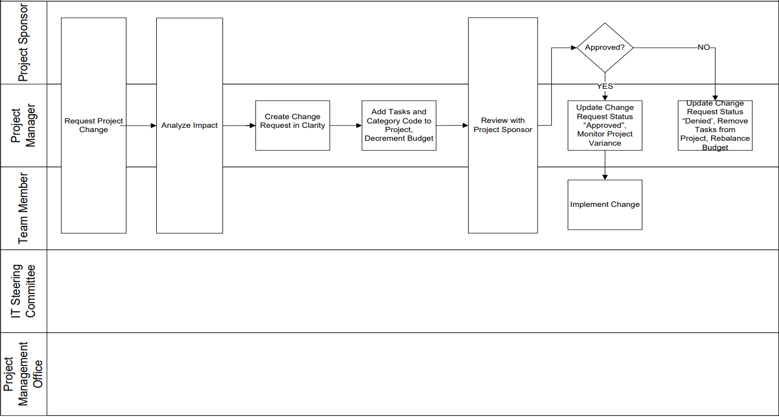

* Project Renegotiation

Some Project Changes may have a significant impact on the project’s cost and schedule. These changes require the project to be renegotiated, approved by the IT Steering Committee, and rebaselined.

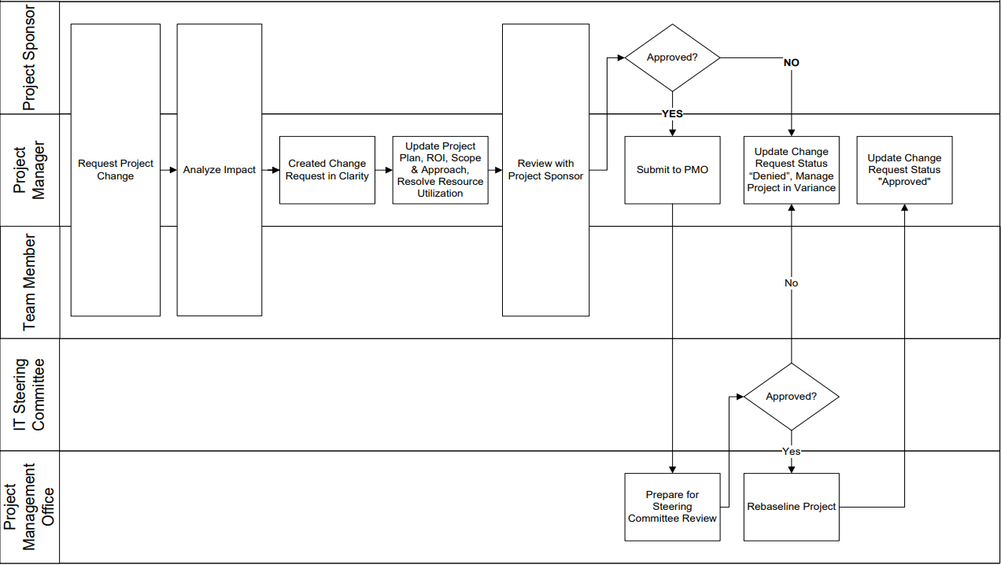

* + 1. **Change** **Request Review**

|  |  |  |
| --- | --- | --- |
| **Role** | **Person** | **Responsibility** |
| Project Director | Mr Nguyen Dinh An | Initiates a change request.  Reviews and approves change requests. |
| Project Manager | Mr Tran Viet Anh Quoc | Initiates a Change Request.  Analyze the impact of Change Requests.  Creates and maintains Change Requests in Clarity.  Reviews with the Project Sponsor and Steering Committee and obtains  approval.  Manages the project’s Scope Management Budget task.  Maintains the project plan. |
| Backend Team  Testing Team  Frontend Team | All members in team | Initiates a Change Request.  Analyzes the impact of Change Requests.  Implements approved Change Requests. |
| IT Director  Scrum Master | Mr Le Trong Hieu  Mrs Truong Van Anh | Reviews and approve Change Requests. |
| Project Management Office | Mr Cao Son Duc | Reviews and monitors the Change Request process.  Monitors project variances. |

* 1. **Issue Management**

Use “clarity issue tracking” issue tracking software.

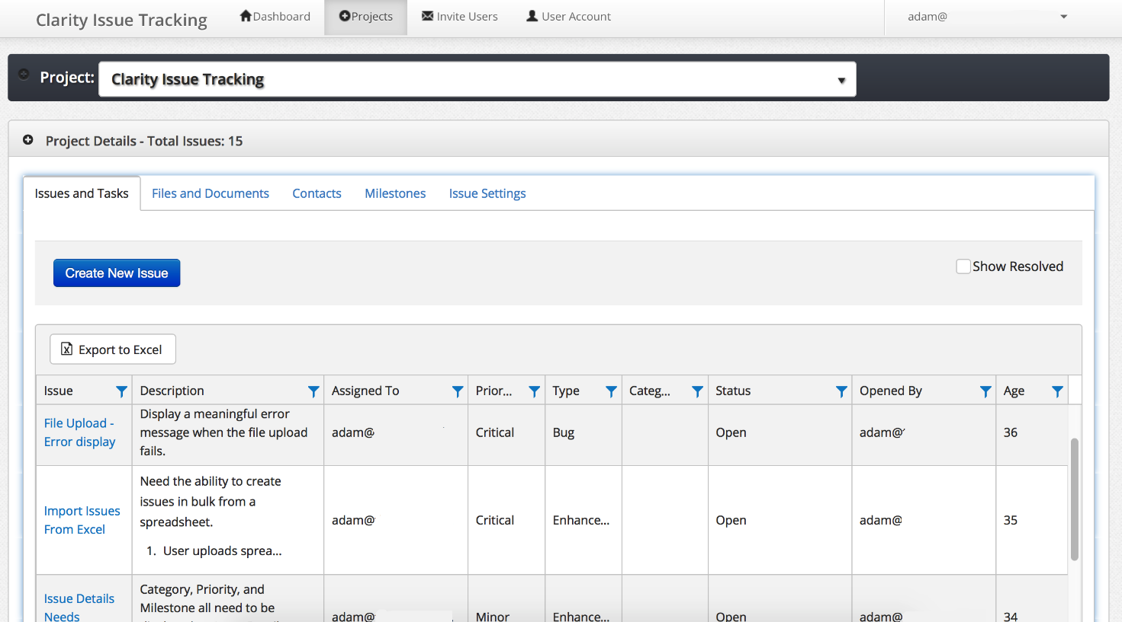

Detailed instruction about this software will be described in another documents.

* 1. **Status Reporting**

A sample Project change request form:

|  |  |
| --- | --- |
| **Field** | **Value** |
| Change request ID | Automatically generated |
| Change request Name | Entered name |
| Description | Summary description text |
| Requested by | Usually Project Manager |
| Status | Approved/Denied/Pending |
| Date | Date time |
| Reason | Approved/Denied reason |
| Comments | Other comments for clarification purpose |
| Deliverables Impacted | Enter in any deliverables that will be impacted |
| Business Justification | Enter the business justification for the Project Change Request. |

.

# Section 5. Quality Management

* 1. **Quality Objectives**

The DanaBus Application Plan identifies three brief goal. Below are the goals and objectives:

* All of main features: find optimal bus route, find bus stop, bus schedule details, estimate waiting time and feedback must be available.
* Help users get the best experience when using the bus service. People will have a habit of using the bus more.
* The application must meet the target of 3.5/5 stars or receive over 100 feedbacks from users on the App Store and Google Play Store.
  1. **Quality Standards**

|  |  |  |
| --- | --- | --- |
| **No.** | **Quality Standard** | **Tracking Tools or Measures** |
| 1 | Six Sigma | Redmine, Jira, clarity issue tracking |
| 2 | IEEE 12207-2017 - ISO/IEC/IEEE | Redmine, clarity issue tracking |
| 3 | AHAQ Coding Convention | GitHub, Jira, clarity issue tracking |

* 1. **Project Reviews and Assessments**

|  |  |  |  |  |
| --- | --- | --- | --- | --- |
| **Review Type** | **Quality Standard** | **Tools** | **Reviewer** | **Reports** |
| Project Report | Six Sigma | Redmine  Jira  clarity issue tracking | IT Director  Project Director  Executive Committee  Project Manager  Stakeholders | Review Report |
| Project Audit | Six Sigma | Redmine  Jira | Business Analyst  Project Manager  Project Director  Executive Committee | Audit Report |
| Daily Review | AHAQ Coding Convention | GitHub  Jira  clarity issue tracking | Backend Team  Frontend Team  Testing Team  Database Analyst  Project Manager  Scrum Master  IT Director | Individual Report |
| Quality Review | Six Sigma | Redmine  Jira  clarity issue tracking | Testing Team  Business Analyst  Project Manager  Scrum Master  Project Director | Quality Report |

* 1. **Deliverables Acceptance**

|  |  |  |
| --- | --- | --- |
| **Deliverable** | **Final Approval Process** | **Customer Acceptance Criteria** |
| Requirements document | Requirements | The requirements that customer give are fully described. |
| Design drawings and documents | Design review 1  Design review 2  Detail Design | Design and documents that meet the requirements have been given before.  Customer satisfy about UI pattern |
| Project plan | Planning  Management | Ensure the stages are properly deployed.  Ensure the budget does not exceed the allowable level.  Ensure products are delivered on given time. |
| Product prototype | Prototyping | The prototype is standardized with design. |
| Beta version application “DanaBus” | Installation  Deployment | All of main features must be available. |
| Completed application “DanaBus” | Installation  Deployment | All of main features: find optimal bus route, find bus stop, bus schedule details, estimate waiting time and feedback must be available. The product operates smoothly and there are no major errors. |
| User document | User document | Full description of the application.  Future maintenance and development capabilities |

* 1. **Process Improvement Activitie****s**

**Project Monthly Report**

* Participants: IT Director, Project Director, Executive Committee, Project Manager, Stakeholders
* Activites and goal: Often a monthly status report is provided to the stakeholder and executive committee as an update of employee’s plans and activities. It also serves as documentation of employee’s work history.
* Goal: Provides a higher-level view of the developments in the project. Stakeholders would usually be interested in tracking the budget, expenditures, the quality of project outputs, and the risks, challenges, and issues affecting the project.

**Daily Review**

* Participants: Project Manager, Backend Team, Frontend Team, Testing Team, Database Analyst, Business Analyst, IT Director
* Activities: Discuss and review the day's work among members.
* Goal: Identify issues, ability to complete tasks and propose methods to complete each stage of the project

# Section 6. Project Transition

* 1. **Closeout Plan**

After all the main requirements are completed, (i.e. 2 mobiles application is fully functioned working), closeout plan will start.

Closeout plan including 3 phases.

Phase 1 is to create all the needed document about this project (including Project Close Out Report).

Phase 2 is to handover the management process to city’s departement of transport.

Phase 3 is the whole team is in “waiting state” for maintenance purposes. If there are any incoming issue or request from city’s person, the team will restart the whole working process of the V-model software development life cycle to upgrade the software.

* 1. **Phase Cl****oseout**

The current contract between our company and city’s government is lasting 5 years. So Phase 2 will close after 5 years if there are no new renew contract request from the customer.

# Section 7. References

|  |  |  |  |
| --- | --- | --- | --- |
| **Document No.** | **Document Title** | **Date** | **Author** |
| 1 | Information Technology Project Management 6th | 2011 | Kathy Schwalbe |
| 2 | Project Structure and Organisation[2] | N/A | N/A |
| 3 | What is PERT and how can we use it?[3] | 2015 | Dave Fourie |
| 4 | V-model wiki[4] | 2019 | N/A |
| 5 | Oakland County Department of Information Technology[5] | N/A | Oakland County Department of Information Technology |

#### 

# Section 8. Glossary

#### Abbreviation:

|  |  |
| --- | --- |
| TMF | Toyota Mobility Foundation |
| DoT | Department of Transportation |
| Danang IIDC | Danang ICT Infrastructure Development Center |
| SDLC | Software Development Life Cycle |
| PERT | Project Evaluation and Review Technique |
| FTE | Full-Time Employed |

* Glossary:

|  |  |
| --- | --- |
| **Word** | **Description** |
| Assumption | Factors deemed to be true during the project planning process, though proof of their validity is not available. |
| Baseline | This term represent the costs and schedules approved at the start of the project. |
| Budget | The sum of money allocated for a project |
| Change control | Change control is the process of identifying, evaluating, approving, and implementing changes to a project. |
| Change management plan | It is created to ensure all changes are managed according to procedure. |
| Critical path activity | A scheduled activity that is part of a project’s critical path. |
| Gantt chart | A type of bar chart that shows all the tasks constituting a project. Tasks are listed vertically, with the horizontal axis marking time. |
| Life cycle | The entire process used to build its deliverables. Life cycles are divided into a number of phases. A variety of life cycle models are in use in project management. |
| Process management | The act of planning, coordinating, and overseeing processes with a view to improving outputs, reducing inputs and energy costs, and maintaining and improving efficiency and efficacy. |
| Project scope statement | A project scope statement details what a project is meant to achieve and describes the deliverables expected. |
| Project stakeholders | Broadly, a Stakeholder is any party which may be affected by a project. |
| Quality assurance | A set of practices designed to monitor processes and provide confidence that result in deliverables meeting quality expectations. |
| Risk | The probability of occurrence of a specific event that affects the pursuit of objectives. |
| Sponsor | A sponsor has ultimate authority over a project. They provide high-level direction, approve project funding as well as deviations from cost and budget, and determine project scope. |
| Steering committee | A steering committee provides high-level strategic guidance on a project. It typically comprises individuals from a number of stakeholder organizations and serves to provide consensus-based direction on projects with a large number or a diversity of stakeholders. |
| V model | The V in V life cycle stands for verification and validation. It is a sequential software development process that matches a corresponding testing phase to each phase in the software development life cycle. During the verification phase, a project team works at increasingly granular levels of detail to identify requirements and design, and then builds the software. Validation proceeds in the opposite direction, as testers examine software components in turn before moving on to systems testing and finally checking that the project as a whole meets requirements. |

# Section 9. Revision History

|  |  |  |  |
| --- | --- | --- | --- |
| **Version** | **Date** | **Name** | **Description** |
| 1st | 2019, March 15th | Project Initiation | Identify project scope, assumption, constraints,... |
| 2nd | 2019, April 12th | Project Start | Complete Project Plan |

#### 

# Section 10. Appendices

N/A

1. https://standards.ieee.org/standard/12207-2017.html
2. https://www.epmbook.com/structure.htm
3. https://www.linkedin.com/pulse/what-pert-how-can-we-use-dave-fourie-pmp-prince2-/
4. https://en.wikipedia.org/wiki/V-Model_(software_development)
5. https://www.oakgov.com/it/pmo/Documents/IT%20Documents/Project%20Management%20Handbook/Handbk04.pdf?fbclid=IwAR1758LijnvawBfraKoc8uFybFOQegpDVwRFcyTQZQQVV5oQQCy4PU9b1MY